6.0 – Vectors and Matrices
Formulating and fitting regression models in matrix notation is much cleaner and computationally efficient. When fitting regression models statistical software uses matrix algebra to fit the models. If you are unfamiliar with matrix algebra this section will certainly be challenging from a mathematical perspective. Fortunately moving forward we won’t need to worry about much of the mathematics presented here. To help digest this material, I strongly suggest you read A.6 in the Weisberg (3rd and 4th ed.) and/or section 7.9 in the Cook & Weisberg text. I will also give you a handout showing matrix calculations done in R including fitting a regression model using matrices.
6.1 – Simple Linear Regression Model in Matrix Notation
Given a random sample $\left(x_{1},y_{1}\right),…, (x_{n},y_{n})$ the data model for a simple linear regression where the mean function is given by $E\left(Y | X\right)=β_{o}+β_{1}X$ we have
$$y_{i}=β_{o}+β_{1}x_{i}+e_{i} i=1,…,n$$
Using vectors and matrices we can write this model as:
$$\left(\begin{matrix}y_{1} \\ y_{2} \\ \begin{matrix}… \\ y_{n-1} \\ y_{n}\end{matrix}\end{matrix}\right)=\left(\begin{matrix}1 & x_{1} \\ 1 & x_{2} \\ \begin{matrix}… \\ 1 \\ 1\end{matrix} & \begin{matrix}… \\ x_{n-1} \\ x_{n}\end{matrix}\end{matrix}\right)\left(\begin{matrix}β_{o} \\ β_{1}\end{matrix}\right)+\left(\begin{matrix}e_{1} \\ e_{2} \\ \begin{matrix}… \\ e_{n-1} \\ e_{n}\end{matrix}\end{matrix}\right)$$
or
$$Y=Xβ+e$$

Using OLS to obtain parameter estimates we choose $(β_{o},β_{1})$ to minimize the RSS:
$$RSS\left(β_{o},β_{1}\right)=\sum_{i=1}^{n}{{\left(y_{i}-\left(β_{o}+β_{1}x_{i}\right)\right)}^{2}=\sum_{i=1}^{n}{e_{i}^{2}}}$$
Using vectors and matrices we can write the RSS as
$$RSS\left(β\right)={\left(Y-Xβ\right)}^{T}\left(Y-Xβ\right)=e^{T}e$$
Multiplying this expression out we have
$$RSS\left(β\right)=Y^{T}T+β^{T}\left(X^{T}X\right)β-2Y^{T}Xβ$$
Taking the derivative with respect to the parameter vector ($β)$ and setting the equation to zero will allow us to solve for $β$ that minimizes RSS($β)$.
$$2\left(X^{T}X\right)β-2X^{T}Y=0$$
$$\left(X^{T}X\right)β=X^{T}Y$$
$$\hat{β}={\left(X^{T}X\right)}^{-1}X^{T}Y$$
OLS Estimate for $β$

Thus the fitted values $(\hat{Y})$ are given by
$$\hat{Y}=X\hat{β}=X{\left(X^{T}X\right)}^{-1}X^{T}Y=HY →{\hat{y}}_{i}=\sum_{j=1}^{n}{h_{ij}y_{j}}$$
The matrix $H$ is called the Hat Matrix because it puts the hat ($^$) on the $Y.$
The residuals $(\hat{e})$ are given by
$$\hat{e}=\left(Y-\hat{Y}\right)=\left(Y-HY\right)=\left(I-H\right)Y$$
The RSS is given by
$$RSS= {\hat{e}}^{T}\hat{e}={\left(Y-\hat{Y}\right)}^{T}\left(Y-\hat{Y}\right)=\sum_{i=1}^{n}{{\hat{e}}_{i}^{2}}$$
Thus the estimated conditional variance $\hat{Var}\left(Y | X\right)={\hat{σ}}^{2}$ is given by
$${\hat{σ}}^{2}=\frac{{\hat{e}}^{T}\hat{e}}{n-2} .$$

Variances and Standard Errors
We won’t see the mathematical details but one can show that
$$Var\left(\hat{β}\right)={\hat{σ}}^{2}{\left(X^{T}X\right)}^{-1}$$
In case of simple linear regression where $E\left(Y | X\right)=β_{o}+β_{1}X$ this will be a 2 x 2 matrix with the following elements.
$$Var(\hat{β})= \left(\begin{matrix}Var({\hat{β}}_{o}) & Cov({\hat{β}}_{o},{\hat{β}}_{1}) \\ Cov({\hat{β}}_{o},{\hat{β}}_{1}) & Var({\hat{β}}_{1})\end{matrix}\right)$$
The square roots of the diagonal elements of this matrix will give the standard errors for the both parameter estimates. The off-diagonal elements are equal, so this is a symmetric matrix, and give the covariance the parameter estimates. Recall the covariance only tells us whether the association is positive or negative. To understand this in the case of simple linear regression see diagrams below.
$Cov\left({\hat{β}}_{o},{\hat{β}}_{1}\right)<0 (\overline{x}>0)$ $Cov\left({\hat{β}}_{o},{\hat{β}}_{1}\right)>0 (\overline{x}<0)$

Standard Errors for Confidence and Prediction
For estimating the mean of the response given ${x^{*}}^{T}=(1 x^{*})$
$$SE\left(\hat{E}\left(Y | X=x^{*}\right)\right)=sefit\left(\hat{y} | x^{*}\right)=\hat{σ}\sqrt{{x^{*}}^{T}{\left(X^{T}X\right)}^{-1}x^{*}}$$
For estimating the response value for an individual with ${x^{*}}^{T}=(1 x^{*})$
$$SE\left({\tilde{y}}^{*} | x^{*}\right)=sepred\left({\tilde{y}}^{*} | x^{*}\right)=\hat{σ}\sqrt{1+{x^{*}}^{T}{\left(X^{T}X\right)}^{-1}x^{*}}$$

Example 6.1: Length and Scale Radius of 4-year Old Smallmouth Bass
Consider again the smallmouth bass data from West Bearskin Lake, but restricting our attention to only fish determined to be 4-years old. These data are given below. We will now use R to perform the matrix operations to obtain most the output shown in the regression summary from JMP. The model used will be $E\left(Length | Scale\right)=β_{o}+β_{1}Scale$ and $Var\left(Length | Scale\right)=constant=σ^{2}.$
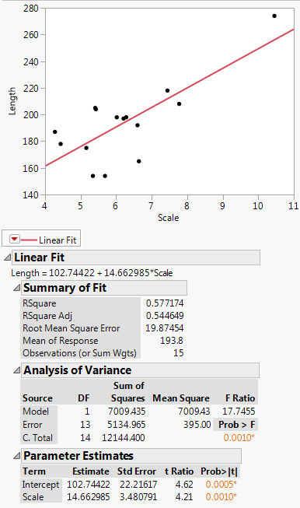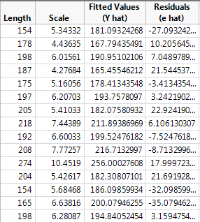
> Bass4 = read.table(file.choose(),header=T,sep=",")
> names(Bass4)
[1] "Length" "Scale"
> dim(Bass4)
[1] 15 2
> Ones = rep(1,15)
> Ones
[1] 1 1 1 1 1 1 1 1 1 1 1 1 1 1 1

Form the model matrix ($X$) with a column of ones for the intercept and a column for scale radii.
> X = cbind(Ones,Scale=Bass4$Scale)
> X
Ones Scale
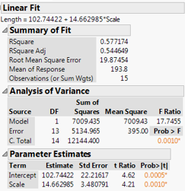
[1,] 1 5.34332
[2,] 1 4.43635
[3,] 1 6.01561
[4,] 1 4.27684
[5,] 1 5.16056
[6,] 1 6.20703
[7,] 1 5.41033
[8,] 1 7.44389
[9,] 1 6.60033
[10,] 1 7.77257
[11,] 1 10.45190
[12,] 1 5.42617
[13,] 1 5.68468
[14,] 1 6.63816
[15,] 1 6.28087

Form response vector Y
> Y = Bass4$Length

Obtain parameter estimates $\hat{β}={\left(X^{T}X\right)}^{-1}X^{T}Y$
> betahat = solve((t(X)%*%X))%*%t(X)%*%Y
> betahat
[,1]
Ones 102.74422
Scale 14.66299
> yhat = X%*%betahat
> yhat
[,1]
[1,] 181.09
[2,] 167.79
[3,] 190.95
[4,] 165.46
[5,] 178.41
[6,] 193.76
[7,] 182.08
[8,] 211.89
[9,] 199.52
[10,] 216.71
[11,] 256.00
[12,] 182.31
[13,] 186.10
[14,] 200.08
[15,] 194.84

Using the Hat Matrix ($H$) and the fact that $\hat{Y}=X{\left(X^{T}X\right)}^{-1}X^{T}Y= HY$
> H = X%*%solve(t(X)%*%X)%*%t(X)
> yhat = H%*%Y
> yhat
[,1]
[1,] 181.09
[2,] 167.79
[3,] 190.95
[4,] 165.46
[5,] 178.41
[6,] 193.76
[7,] 182.08
[8,] 211.89
[9,] 199.52
[10,] 216.71
[11,] 256.00
[12,] 182.31
[13,] 186.10
[14,] 200.08
[15,] 194.84

Form residual vector $e=(Y-\hat{Y})$
> e = Y - yhat
> e
[,1]
[1,] -27.0932
[2,] 10.2056
[3,] 7.0490
[4,] 21.5445
[5,] -3.4134
[6,] 3.2422
[7,] 22.9242
[8,] 6.1061
[9,] -7.5248
[10,] -8.7133
[11,] 17.9997
[12,] 21.6919
[13,] -32.0986
[14,] -35.0795
[15,] 3.1595

Find $RSS= {\hat{e}}^{T}\hat{e}$
> RSS = t(e)%*%e
> RSS
[,1]
[1,] 5134.9654

Find $\hat{Var}\left(Length | Scale\right)={\hat{σ}}^{2}={RSS}/{(n-2)}$
> varhat = RSS/(15-2)
> varhat
[,1]
[1,] 394.99734

Find variance and standard errors of the parameter estimates $Var\left(\hat{β}\right)={\hat{σ}}^{2}{\left(X^{T}X\right)}^{-1}$
> varbetas = 394.997*solve(t(X)%*%X)
> varbetas
Ones Scale

Ones 493.557891 -75.238604
Scale -75.238604 12.115898
> SEbo = sqrt(493.558)
> SEb1 = sqrt(12.116)
> SEbo
[1] 22.216165
> SEb1
[1] 3.4808045
> lm1 = lm(Bass4$Length~Bass4$Scale)
> summary(lm1)

Call:
lm(formula = Bass4$Length ~ Bass4$Scale)

Residuals:
Min 1Q Median 3Q Max
-35.0795 -8.1190 3.2422 14.1027 22.9242

Coefficients:
Estimate Std. Error t value Pr(>|t|)
(Intercept) 102.7442 22.2162 4.6247 0.0004758 ***
Bass4$Scale 14.6630 3.4808 4.2125 0.0010156 **
---
Signif. codes: 0 ‘***’ 0.001 ‘**’ 0.01 ‘*’ 0.05 ‘.’ 0.1 ‘ ’ 1

Residual standard error: 19.875 on 13 degrees of freedom
Multiple R-squared: 0.57717, Adjusted R-squared: 0.54465
F-statistic: 17.746 on 1 and 13 DF, p-value: 0.0010156

> SYY = sum((Y-mean(Y))^2)
> SYY
[1] 12144.4
> RSS
[,1]
[1,] 5134.9654

> Rsquare = (SYY-RSS)/SYY
> Rsquare
[,1]
[1,] 0.57717422

> sqrt(varhat)
[,1]
[1,] 19.87454

> Fstat = SSreg/varhat
> Fstat
[,1]
[1,] 17.745523
> pf(17.7455,1,13,lower.tail=F)
[1] 0.0010155555
Confidence and Prediction Intervals from JMP
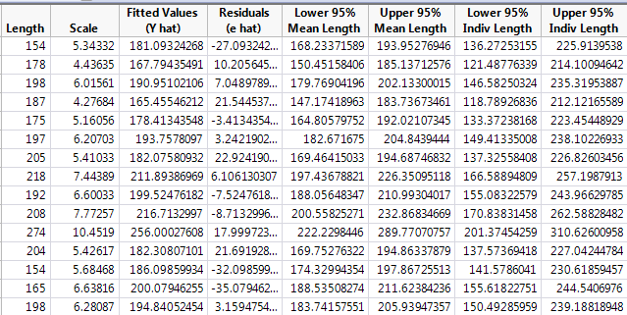

In R

> xnew = c(1,5.34332)
> yhatstar = xnew%*%betahat
> yhatstar
[,1]
[1,] 181.09324

Compute $SE\left(\hat{E}\left(Length | Scale=5.34332\right)\right)= \hat{σ}\sqrt{{x^{*}}^{T}{\left(X^{T}X\right)}^{-1}x^{*}}$
> sefit=sigmahat*sqrt(t(xnew)%*%solve(t(X)%*%X)%*%xnew)
> sefit
[,1]
[1,] 5.9524687

Find $t(α/{2,n-2)}$ $α=.05 and n-2=15-2=13$
> qt(.975,13)
[1] 2.1603687

Find LCL and UCL
> LCL = yhatstar - 2.1603687*sefit
> UCL = yhatstar + 2.1603687*sefit
> cbind(LCL,UCL)
[,1] [,2]
[1,] 168.23372 193.95277 this matches the results from JMP in the table above.

Compute $SE\left(\tilde{Length^{*}} | Scale=5.34332\right)=\hat{σ}\sqrt{1+{x^{*}}^{T}{\left(X^{T}X\right)}^{-1}x^{*}}$
> sepred=sigmahat*sqrt(1+t(xnew)%*%solve(t(X)%*%X)%*%xnew)
> sepred
[,1]
[1,] 20.746788

Find LPL and UPL (P = Prediction)
> LPL = yhatstar - 2.1603687*sepred
> UPL = yhatstar + 2.1603687*sepred
> cbind(LPL,UPL)
[,1] [,2]
[1,] 136.27253 225.91395 this matches the results from JMP in the table above.

